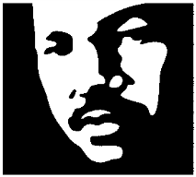 King County
Town Hall/Open House
King County Community Service Area Program
FAIRWOOD COMMUNITY
Residents of unincorporated King County are invited to meet with County officials to discuss issues affecting unincorporated Fairwood
Wednesday, May 16 7:00 to 9:00 PM
Northwood Middle School
17007 SE 184th Street, Renton
Featuring
- County Councilmember Reagan Dunn
- King County Sheriff
- Information on King County Local Services Initiative
For more information contact Alan Painter, Program Manager, Community Services Area Program
206 477-4521 or alan.painter@kingcounty.gov
Interpreter services available upon request

